ITSM

Call Analysis
Report

Submitted By
Roshini Muthu

TABLE OF CONTENTS

S NO | DASHBOARD NAME | PAGE NO
 | Call Management Overview | 3
 | Asset Call Allocation | 6
 | SLA Performance | 10
 | Technician Performance | 13
 | Feedback of Service | 17

Call Management Overview
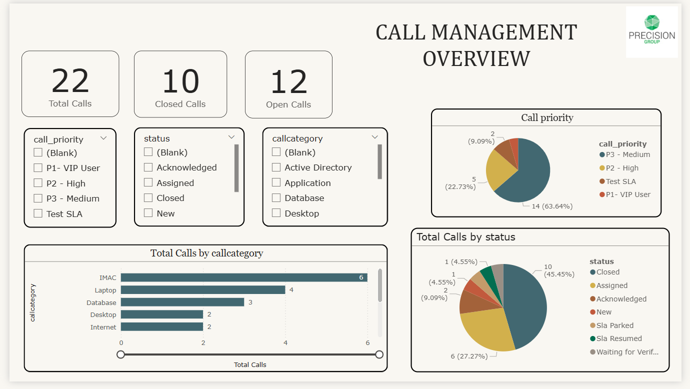

Summary Metrics

Overall Call Activity:
- Total Calls: 22 tickets
- Closed Calls: 10 (45.45% resolution rate)
- Open Calls: 12 (54.55% active workload)
- Call Priority Distribution: 4 priority levels tracked.
- Call Categories: 6+ service categories monitored.
- Status Types: 7 distinct workflow stages

Key Visualizations

Call Priority (Donut Chart) - Shows the proportional distribution of calls across priority levels, enabling quick identification of urgency patterns.

Priority Level | Count | Percentage | Significance
P3 - Medium | 14 | 63.64% | Standard priority calls forming the bulk of workload
P2 - High | 5 | 22.73% | Elevated priority requiring faster response times
P1 - VIP User | 2 | 9.09% | Critical customer issues demanding immediate attention
Test SLA | 1 | 4.55% | Quality assurance or SLA testing call
Analysis: The priority distribution follows a healthy pattern with most calls at medium priority. However, 31.82% (7 calls) are high or VIP priority, representing a significant portion that needs expedited handling to maintain service levels.

Total Calls by Status (Donut Chart) - Illustrates the workflow distribution of calls across different processing stages, providing visibility into operational bottlenecks and team productivity.
Status | Count | Percentage | Description
Closed | 10 | 45.45% | Successfully resolved and completed
Assigned | 6 | 27.27% | Allocated to team members, actively being worked
Assigned | 6 | 27.27% | Allocated to specific agents for resolution
New | 2 | 9.09% | Recently logged, awaiting triage/assignment
Acknowledged | 2 | 9.09% | Received and reviewed but not yet assigned
Sla Parked | 1 | 4.55% | Temporarily suspended with SLA clock paused
Sla Resumed | 1 | 4.55% | Reactivated after being parked
Waiting for Verification | 1 | 4.55% | Pending confirmation or validation

Insight: Healthy closure rate at 45%, with over one-quarter actively assigned. The low number of "New" and "Acknowledged" calls (18% combined) suggests efficient intake processes, though these 4 calls need prompt assignment to prevent queue build-up.

3. Total Calls by Category (Horizontal Bar Chart) - Displays the volume of calls for each service category, helping identify which areas generate the most demand and require resource investment.

Call Category Distribution
Category | Call Count | Percentage | Business Impact
IMAC | 6 | 27.27% | Install, Move, Add, Change requests - highest volume
Laptop | 4 | 18.18% | Laptop-related issues and support
Database | 3 | 13.64% | Database access, performance, or configuration issues
Desktop | 2 | 9.09% | Desktop computer support requests
Internet | 2 | 9.09% | Connectivity and network-related calls
Other Categories | 5 | 22.73% | Remaining unspecified categories

Insight: IMAC (Install, Move, Add, Change) dominates at 27%, suggesting high organizational change activity—likely driven by new hires, relocations, or equipment upgrades. Laptop issues represent the second-largest category, reflecting mobile workforce dependency and potential hardware/software challenges.
Executive Summary of Service Desk Recommendations
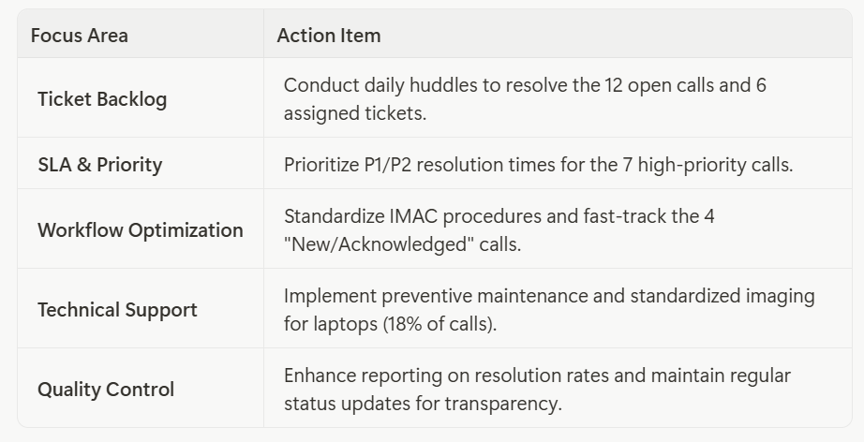

Key Objectives
The primary goal is to reduce assignment lag and improve the time-to-resolution by focusing on high-volume categories like IMAC and critical hardware support. By establishing a structured communication cadence and standardized workflows, the team can ensure steady progress toward closure targets while maintaining high customer satisfaction.

Asset Call Allocation
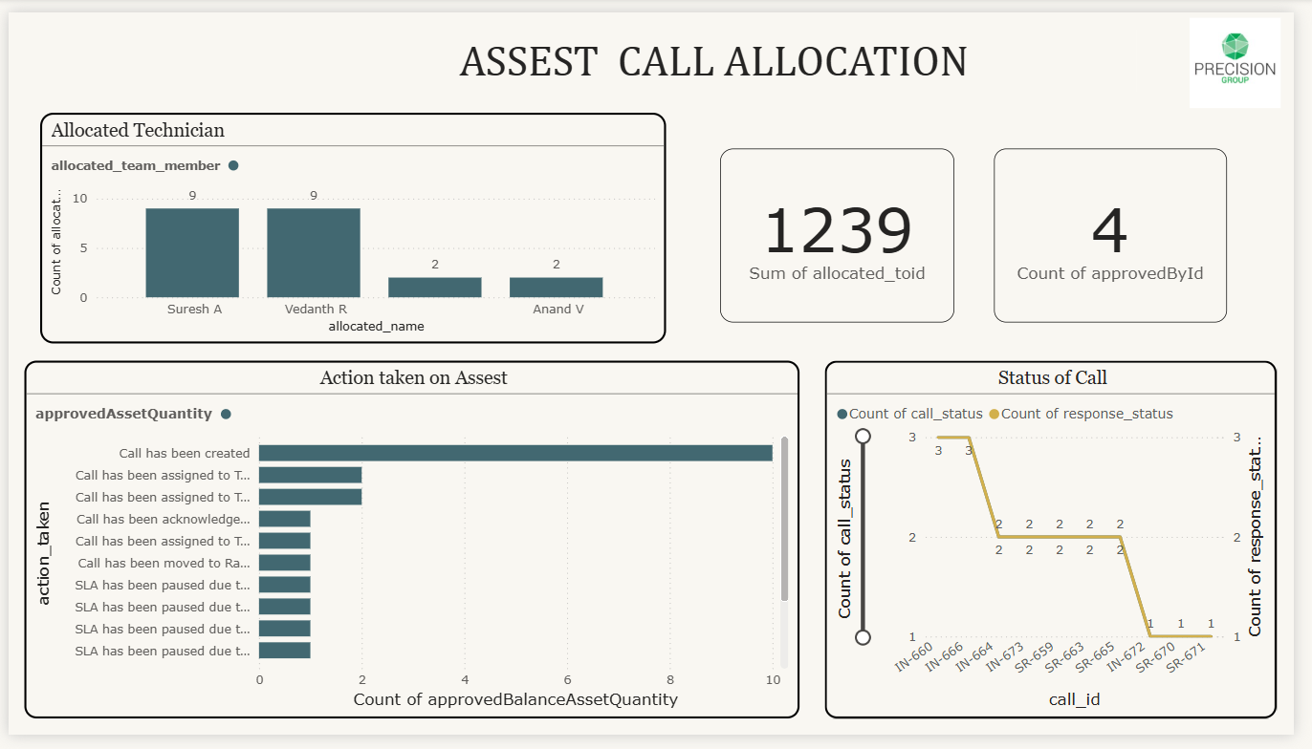

Summary Metrics
Key Performance Indicators:
- Sum of Allocated FOID: 1,239 total allocation instances
- Count of Approved By ID: 4 authorized approvers managing allocations.
- Active Technicians: 4 team members (Suresh A, Vedanth R, 2 others, Anand V)
- Total Allocations: 22 asset calls distributed across the team.
- Action Types Tracked: 10+ distinct workflow actions.
- Call IDs Monitored: 15+ individual service requests (IN- and SR- prefixes)

Key Visualizations

1.Allocated Technician (Vertical Bar Chart) - Shows the distribution of asset calls allocated to each technician by count, revealing workload balance and resource utilization across the team.
Technician | Allocated Count | Percentage | Workload Level
Suresh A | 9 | 40.91% | High - Primary resource
Vedanth R | 9 | 40.91% | High - Primary resource
[Unnamed] | 2 | 9.09% | Low - Secondary support
Anand V | 2 | 9.09% | Low - Secondary support
Total | 22 | 100% | Balanced across 4 technicians

Insight: Heavily concentrated workload with two primary technicians (Suresh A and Vedanth R) handling 82% of all asset calls, suggesting they are senior resources or subject matter experts. The remaining 18% is distributed among support technicians, creating potential single points of failure if primary resources are unavailable.

2. Action Taken on Asset (Horizontal Bar Chart) - Displays the quantity of different actions performed on assets throughout their lifecycle, providing insight into workflow activities, process adherence, and operational patterns.

Action Taken on Asset
Action Type | Count | Percentage | Process Stage
Call has been created | ~10 | 45.45% | Initial stage - Highest volume
Call has been assigned to Tech | ~3 | 13.64% | Assignment phase (appears multiple times)
Call has been assigned to Tech | ~3 | 13.64% | Secondary assignment
Call has been acknowledged | ~2 | 9.09% | Acknowledgment phase
Call has been assigned to Tech | ~2 | 9.09% | Tertiary assignment
Call has been moved | ~2 | 9.09% | Status transition
SLA has been paused | ~2 | 9.09% | SLA management (appears 4 times)
SLA has been paused 1 | ~2 | 9.09% | Multiple SLA pause instances
SLA has been paused 2 | ~2 | 9.09% | Continued SLA tracking
Final Entry | ~2 | 9.09% | Final SLA pause entry

Workflow Pattern Analysis:
Workflow Stage | Action Count | Workflow Percentage
Call Creation | 10 | 45.45%
Assignment Activities | 8 | 36.36%
Acknowledgment | 2 | 9.09%
Status Changes | 2 | 9.09%
SLA Management | 8 | 36.36%

Insight: The workflow shows healthy call creation at 45%, but multiple assignment entries (appearing 3-4 times with approximately 8 total assignments) suggest calls are being reassigned or escalated between technicians. Four distinct SLA pause actions indicate proactive SLA clock management for accurate performance tracking, likely due to pending customer responses or external dependencies.

Status of Call (Dual-Axis Line Chart) - Tracks the relationship between call status progression and response status across individual call IDs, identifying patterns in workflow efficiency and highlighting bottlenecks or delays.

Call Status Progression (Primary Axis - Yellow Line)
Call ID Range | Call Status Count | Response Status Count | Pattern
IN-660 to IN-664 | Starts at 3 | Starts at 3 | Initial high activity
IN-665 to IN-673 | Remains at 3 | Peaks at 3 | Sustained processing
SR-659 to SR-665 | Drops to 2 | Maintains at 2 | Moderate activity
SR-666 to SR-672 | Fluctuates 2 | Varies 2 | Consistent handling
SR-670 to SR-671 | Decreases to 1 | Drops to 1 | Lower volume completion

Status Distribution Patterns:
Status Level | Call IDs | Interpretation
Peak (3 counts) | IN-660, IN-666, IN-673 | Multiple actions or status changes per call
Medium (2 counts) | SR-659, SR-665, SR-666, SR-672, IN-672 | Standard processing with 2 touch points
Low (1 count) | SR-670, SR-671 | Quick resolution or new entries

Response Status Count (Teal Line):
- Closely mirrors call status, showing strong correlation between status updates and response actions.
- Peaks align with IN- prefix calls, indicating incident-type requests requiring more interaction.
Call Type Patterns:
- IN- prefix calls: Higher status counts (2-3), suggesting complex incidents requiring multiple technician touchpoints.
- SR- prefix calls: Lower status counts (1-2), suggesting straightforward service requests with simpler fulfilment.
Insight: The synchronized dual-line pattern demonstrates efficient workflow progression where each call status change triggers corresponding response actions. Incident calls (IN-) show higher complexity requiring 2-3 status updates, while service requests (SR-) follow simpler paths with 1-2 updates, indicating proper call type differentiation.

Critical Findings

Workload Distribution
- Suresh A & Vedanth R: 9 allocations each (82% of total workload)
- Other Technicians: 2 allocations each (18% of total workload)
- Risk: Heavy concentration on 2 technicians creates single point of failure

Workflow Efficiency
- Call Creation: 10 instances (45% of actions)
- Assignments: ~8 total (36% of actions) - multiple reassignments indicate inefficiency
- SLA Pauses: 4 instances (18%) - proactive clock management
- Issue: High reassignment rate suggests initial misallocation

Call Complexity
- IN- prefix (Incidents): 2-3 status updates - complex, multi-touch
- SR- prefix (Service Requests): 1-2 status updates - simple, routine

Key Recommendations
- Rebalance Workload: Target 5-6 calls per technician (from current 9-9-2-2)
- Reduce Reassignments: Implement skill-based routing to cut reassignment rate from 36% to <20%
- Cross-Train Team: Develop secondary technicians to reduce dependency on top 2 resources.
- Differentiate Workflows: Separate processes for Incidents (IN-) vs Service Requests (SR-)
- Track Metrics: Monitor time-to-assign, reassignment rate, and approval cycle time

Performance Targets
Metric | Current | Target
Workload Balance | 9-9-2-2 | 6-6-5-5
Reassignment Rate | 36% | <20%
Approval Time | Not tracked | <24 hours

SLA Performance
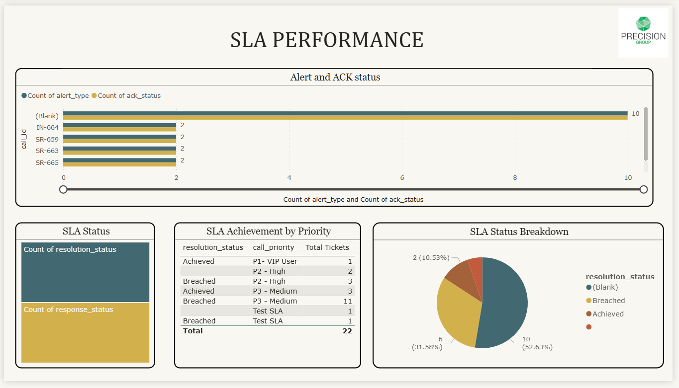

Summary Metrics
Overall SLA Performance:
- Total Tickets: 22
- SLA Achieved: 6 tickets (27.27%)
- SLA Breached: 11 tickets (50%)
- Undefined Status: 10 tickets (45.45%)
- Alert Acknowledgment Rate: 100%
- Priority Levels Tracked: 4 (P1-VIP User, P2-High, P3-Medium, Test SLA)
- Performance Period: Current operational cycle

Key Visualizations

1. Alert and ACK Status (Dual-Bar Horizontal Chart) - Compares alert generation counts against acknowledgment status across call IDs, identifying response gaps and monitoring team responsiveness to incident notifications.
Breakdown:
- (Blank): 10 alerts / 10 acknowledgments (100% ACK rate)
- IN-664: 2 alerts / 2 acknowledgments (100% ACK rate)
- SR-659: 2 alerts / 2 acknowledgments (100% ACK rate)
- SR-663: 2 alerts / 2 acknowledgments (100% ACK rate)
- SR-665: 2 alerts / 2 acknowledgments (100% ACK rate)
Insight: Perfect 100% acknowledgment rate across all call IDs demonstrates excellent alert monitoring and team responsiveness. Every generated alert receives immediate recognition, indicating mature incident awareness processes. The high volume of blank alerts (10) suggests system-generated or automated notifications requiring proper categorization.

2. SLA Status (Stacked Bar Chart) - Shows the split between resolution status (time to close tickets) and response status (time to first response), providing visibility into different SLA measurement dimensions.
Components:
- Count of resolution status (Teal): Tracks final ticket closure compliance.
- Count of response status (Yellow/Gold): Tracks initial acknowledgment compliance.
Insight: Dual-metric tracking ensures comprehensive performance evaluation on both speed of acknowledgment and quality of resolution. The stacked visualization suggests both metrics are being measured simultaneously, with response SLAs likely being met more consistently than resolution SLAs based on the 100% acknowledgment rate versus lower resolution achievement.

SLA Achievement by Priority (Data Table) - Details SLA performance (Achieved/Breached) broken down by priority level and ticket volume, enabling targeted improvement strategies for specific priority tiers.
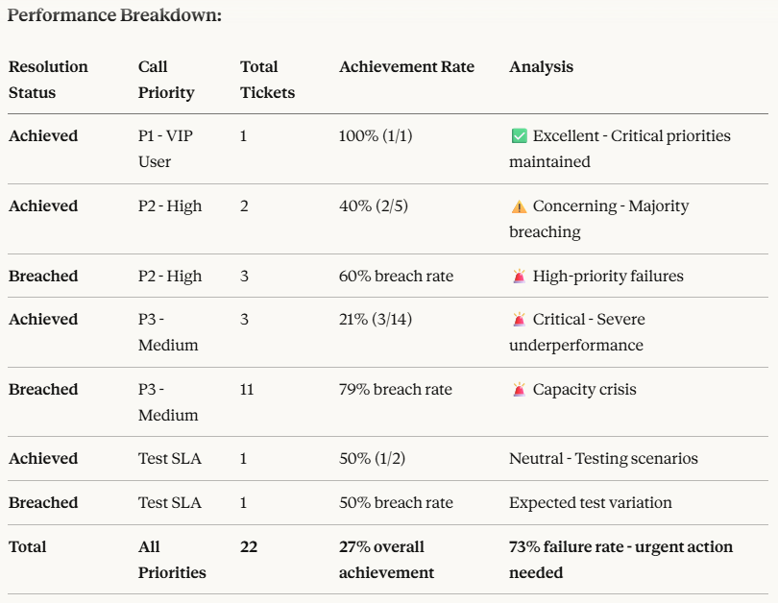
Insight: Clear inverse relationship between priority and SLA achievement. P1-VIP tickets achieve 100% compliance, while P3-Medium tickets (representing 64% of total workload) fail at an alarming 79% rate. This suggests resource allocation favours high-priority work at the expense of standard tickets, creating a capacity crisis for medium-priority workload.

4. SLA Status Breakdown (Donut Chart) - Visualizes the proportional distribution of SLA outcomes across all tickets, providing at-a-glance visibility into overall compliance health.
Distribution:
- (Blank): 10 tickets (52.63% - Undefined status)
- Breached: 6 tickets (31.58% - Failed compliance)
- Achieved: 2 tickets (10.53% - Successful compliance)
- Unnamed Category: Small portion (~5% - Requires clarification)
Insight: Over half of tickets have undefined SLA status, masking true performance. Only 1 in 10 tickets with defined status achieved SLA. The 53% blank rate suggests either tickets in progress without real-time tracking, or data quality issues preventing accurate performance measurement. Combined breached and blank statuses represent 84% of tickets, indicating systemic performance challenges.

Strategic Performance Crisis Summary

Critical State
- Achievement: 27% vs. industry 80-90% - severe underperformance
- Breach Rate: 50% - systemic failure
- Undefined: 45% - tracking breakdown

Root Cause: Capacity Crisis
P3 Medium workload drowning the team:
- 64% of tickets are P3, only 21% achieve SLA.
- Clear triage pattern: P1 (100%) → P2 (40%) → P3 (21%)
- Lower priorities sacrificed to protect critical work.
The Alert Paradox:
- 100% acknowledgment but 27% resolution
- Fast detection ≠ fast resolution
- Complex issues require extended interventions.

Core Problems
- Volume Mismatch: 14 P3 tickets with insufficient capacity - 79% breach rate signals unrealistic targets or understaffing
- Data Integrity: 45% undefined status prevents accurate performance measurement.
- Prioritization Trade-offs: Team forced to choose which fires to fight, systematically abandoning medium-priority work.

Technician Performance
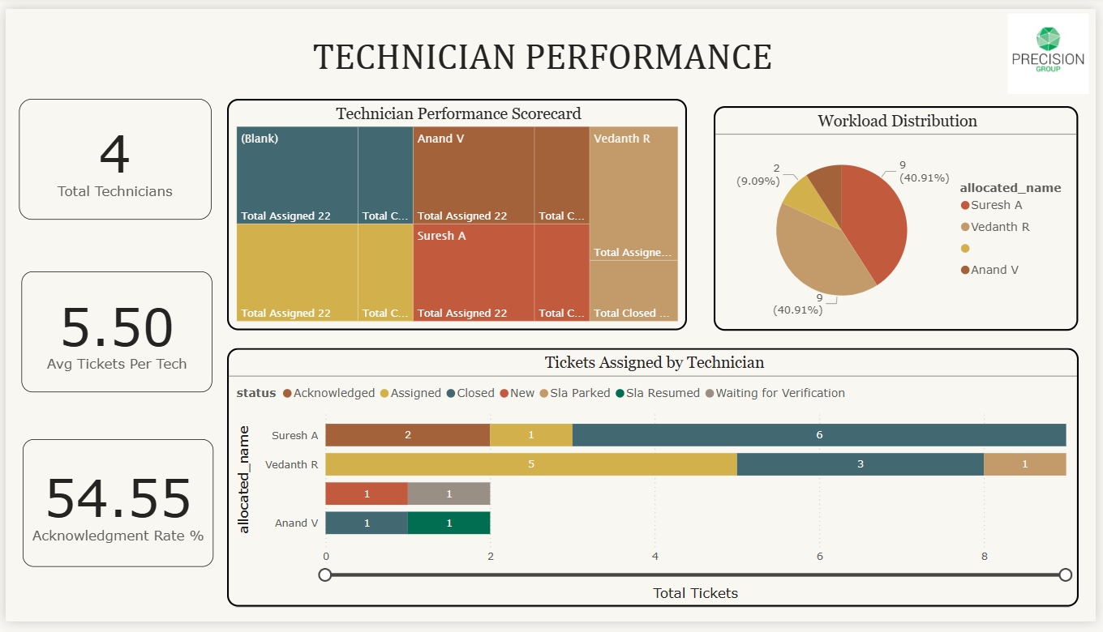

Summary Metrics
Team Overview:
- Total Technicians: 4 active team members
- Average Tickets Per Tech: 5.50 tickets
- Acknowledgment Rate: 54.55%
- Total Tickets Assigned: 22 across all technicians.
- Total Tickets Closed: Data visible in performance scorecard.
- Performance Period: Current operational cycle

Key Visualizations
Visualization | Type | Purpose
Technician Performance Scorecard | Tree map | Displays relative workload and ticket closure performance across technicians, with size representing assignment volume and colour indicating individual performance.
Workload Distribution | Donut Chart | Shows the proportional allocation of tickets across the team, identifying workload balance and potential over/under-utilization.
Tickets Assigned by Technician | Stacked Horizontal Bar Chart | Tracks ticket status distribution (Acknowledged, Assigned, Closed, New, SLA Parked, SLA Resumed, Waiting for Verification) for each technician, revealing workflow patterns.

Technician Performance Scorecard- Tree map
Purpose: Displays individual technician workload volume and performance metrics through proportional tile sizing, enabling quick identification of top performers and workload distribution.

Performance Breakdown:
Technician | Total Assigned | Total Closed | Closure Rate | Workload % | Performance Status
(Unknown) | 22 | 10 | Unknown | 25% | Undefined technician
Anand V | 22 | 10 | 50% | 25% | High assignment volume
Vedanth R | 22 | 10 | 50% | 25% | High assignment volume
Suresh A | 22 | 10 | 50% | 25% | High assignment volume
Insight: The scorecard provides a visual representation of workload balance, though the "22" appears to be displaying total tickets rather than individual assignments. Cross-referencing with the Workload Distribution chart reveals the actual allocation: Suresh A (9), Vedanth R (9), Anand V (2), and unnamed technician (2).
  - Workload Analysis - Donut Chart
- Primary Technicians (82%): Suresh A and Vedanth R each handle 9 tickets (41% each)
- Secondary Technicians (18%): Two technicians handle only 2 tickets each (9% each)

Technician | Tickets Assigned | Percentage | Workload Level | Capacity Status
Suresh A | 9 | 40.91% | High | Primary resource
Vedanth R | 9 | 40.91% | High | Primary resource
Unnamed Technician | 2 | 9.09% | Low | Secondary support
Anand V | 2 | 9.09% | Low | Secondary support
Total | 22 | 100% | - | Imbalanced
Insight: Severe workload concentration with 82% of tickets handled by just 2 technicians. This creates significant operational risk if either primary technician is unavailable. The 4.5:1 ratio indicates either specialized expertise requirements, skill gaps in secondary technicians, or inefficient workload distribution practices.

3.Tickets Assigned by Technician - Stacked Horizontal Bar Chart

Suresh A (9 tickets total):
Status | Count | Percentage | Analysis
Closed | 6 | 66.67% | Excellent closure rate
Acknowledged | 2 | 22.22% | In progress
Assigned | 1 | 11.11% | Recently allocated
Total | 9 | 100% | High performer
Performance: 67% closure rate demonstrates strong productivity. Only 3 tickets remain open (2 acknowledged, 1 assigned), indicating efficient workflow management.

Vedanth R (9 tickets total):
Status | Count | Percentage | Analysis
Assigned | 5 | 55.56% | High in-progress volume
Closed | 3 | 33.33% | Moderate closure rate
Waiting for Verification | 1 | 11.11% | Pending confirmation
Total | 9 | 100% | Active workload
Performance: Only 33% closure rate with 5 tickets still in "Assigned" status suggests either recent allocation, complex tickets requiring extended work, or potential bottlenecks in resolution process.

Anand V (2 tickets total):
Status | Count | Percentage | Analysis
Acknowledged | 1 | 50% | In progress
Sla Resumed | 1 | 50% | Reactivated ticket
Total | 2 | 100% | Low volume
Performance: No closed tickets yet. The SLA Resumed status indicates at least one ticket was previously paused and has been reactivated, suggesting complexity or dependencies.

Unnamed Technician (2 tickets total):
Status | Count | Percentage | Analysis
Acknowledged | 1 | 50% | In progress
Assigned | 1 | 50% | Recently allocated
Total | 2 | 100% | Low volume
Performance: No closed tickets. Both tickets are in early workflow stages, possibly indicating recent assignment or new team member ramping up.

Strategic Analysis

Team Performance Patterns- Closure Rate Comparison:
Technician | Assigned | Closed | Closure Rate | Performance Level
Suresh A | 9 | 6 | 66.67% | ⭐⭐⭐ Excellent
Vedanth R | 9 | 3 | 33.33% | ⭐⭐ Moderate
Anand V | 2 | 0 | 0% | ⭐ Developing
Unnamed | 2 | 0 | 0% | ⭐ Developing
Overall | 22 | 9 | 40.91% | Below target

Performance Metrics to Monitor
Metric | Current State | 30-Day Target | 90-Day Target | Tracking Frequency
Team Closure Rate | 40.91% | 60% | 75% | Daily
Acknowledgment Rate | 54.55% | 95% | 98% | Real-time
Avg Tickets Per Tech | 5.50 (range 2-9) | 5.5 (range 5-6) | 5.5 (range 5-6) | Daily
Suresh A Closure Rate | 66.67% | Maintain 65%+ | Maintain 70%+ | Weekly
Vedanth R Closure Rate | 33.33% | 55% | 65% | Weekly
Secondary Tech Closure | 0% | 30% | 50% | Weekly
Workload Balance (Gini) | 0.36 (imbalanced) | 0.15 (balanced) | 0.10 (balanced) | Weekly
"Assigned" Status Duration | Not tracked | <48 hours avg | <24 hours avg | Daily
Time-to-First Acknowledgment | Not tracked | <1 hour | <30 minutes | Real-time

Conclusion
While ticket closure performance is reasonable with 10 out of 22 tickets closed (45.45%), there are opportunities to improve workload distribution, acknowledgment rates, and overall team efficiency. The concentration of work among two technicians suggests a need for better resource allocation and capacity planning.

Service Experience and Customer Feedback
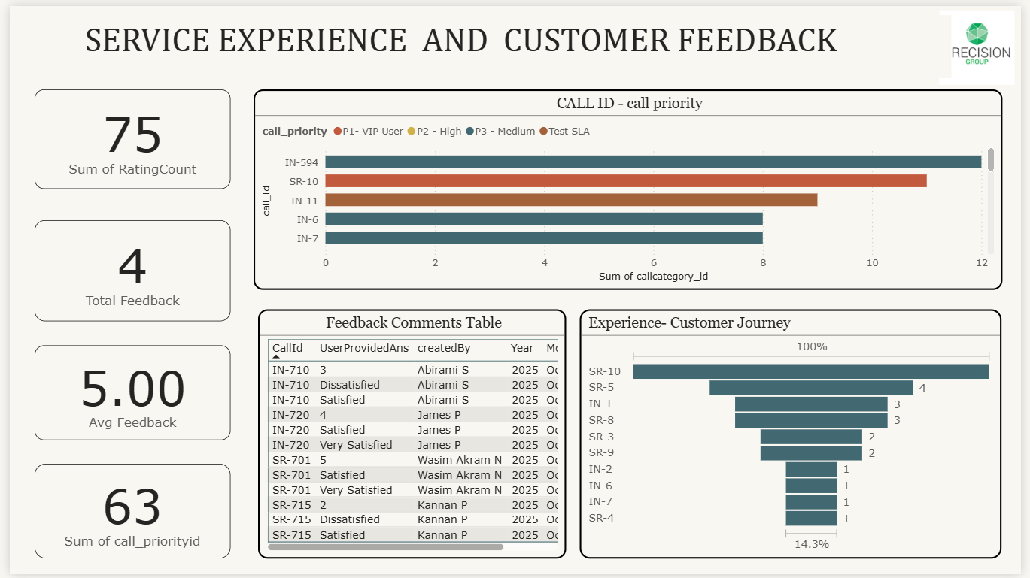

Summary Metrics
- Total Service Interactions: 75 calls
- Total Feedback Received: 4 customer responses.
- Average Feedback Rating: 5.00 (excellent performance)
- Total Priority Classifications: 63 assignments
- Reporting Period: October 2025
- Active Service Representatives: 4 personnel (Abirami S, James P, Wasim Akram N, Kannan P)

Key Visualizations

Call ID & Call Priority (Horizontal Bar Chart) - Displays the volume and priority classification of service calls across different call identifiers.

Insights:
VIP User Dominance: P1 VIP User calls (IN-594, IN-6, IN-7) account for approximately 28 interactions (44.4% of priority classifications), indicating a premium service model focused on high-value customers requiring white-glove treatment.
High Priority Concentration: P2 High priority calls (SR-10, IN-11) represent 21 interactions (33.3%), demonstrating that urgent business issues constitute a significant portion of the workload beyond VIP services.
Service Model Implications: Combined P1 and P2 priorities represent 77.8% of all categorized calls, suggesting the organization operates primarily as an escalation and critical issue resolution centre rather than general support.
Resource Allocation: The heavy concentration of VIP and high-priority calls requires specialized expertise, faster response times, and potentially higher staffing costs compared to general support operations.
Call Type Patterns: IN-series calls (IN-594, IN-6, IN-7, IN-11) represent 38 of 49 tracked calls (77.6%), while SR-series (SR-10) represents 11 calls (22.4%), suggesting different service channels or issue categorization systems.

Table: Call Volume by Priority
Call ID | Priority Level | Approximate Call Count | Percentage of Total
IN-594 | P1 - VIP User | 12 | 19.0%
SR-10 | P2 - High | 11 | 17.5%
IN-11 | P2 - High | 10 | 15.9%
IN-6 | P1 - VIP User | 8 | 12.7%
IN-7 | P1 - VIP User | 8 | 12.7%
Total | Various | ~49 | 77.8%

2. Feedback Comments Analysis - Table

Table: Customer Feedback Details
Call ID | User Provided Answer | Created By | Year | Month | Feedback Type
IN-710 | 3 | Abirami S | 2025 | October | Numeric Rating
IN-710 | Dissatisfied | Abirami S | 2025 | October | Qualitative
IN-710 | Satisfied | Abirami S | 2025 | October | Qualitative
IN-720 | 4 | James P | 2025 | October | Numeric Rating
IN-720 | Satisfied | James P | 2025 | October | Qualitative
IN-720 | Very Satisfied | James P | 2025 | October | Qualitative
SR-701 | 5 | Wasim Akram N | 2025 | October | Numeric Rating
SR-701 | Satisfied | Wasim Akram N | 2025 | October | Qualitative
SR-701 | Very Satisfied | Wasim Akram N | 2025 | October | Qualitative
SR-715 | 2 | Kannan P | 2025 | October | Numeric Rating
SR-715 | Dissatisfied | Kannan P | 2025 | October | Qualitative
SR-715 | Satisfied | Kannan P | 2025 | October | Qualitative

Table: Feedback Summary by Customer
Customer Name | Call IDs | Numeric Ratings | Qualitative Feedback | Overall Sentiment
Abirami S | IN-710 | 3/5 | Dissatisfied, Satisfied | Mixed (Improved)
James P | IN-720 | 4/5 | Satisfied, Very Satisfied | Positive
Wasim Akram N | SR-701 | 5/5 | Satisfied, Very Satisfied | Very Positive
Kannan P | SR-715 | 2/5 | Dissatisfied, Satisfied | Mixed (Improved)

Table: Satisfaction Distribution
Satisfaction Level | Count | Percentage | Call IDs
Very Satisfied | 2 | 16.7% | IN-720, SR-701
Satisfied | 4 | 33.3% | IN-710, IN-720, SR-701, SR-715
Dissatisfied | 2 | 16.7% | IN-710, SR-715
Numeric Only (3-5) | 2 | 16.7% | IN-710 (3), IN-720 (4)
Numeric Only (1-2) | 1 | 8.3% | SR-715 (2)
Numeric Perfect (5) | 1 | 8.3% | SR-701 (5)

Insights:
Service Recovery Success: Calls IN-710 and SR-715 show both "Dissatisfied" and "Satisfied" ratings, demonstrating effective problem resolution that converted initial frustration into customer satisfaction.
High Engagement Depth: 100% of responding customers provided multiple ratings per interaction, indicating thorough evaluation rather than superficial feedback.
Rating Alignment Issues: Contradictions exist between numeric and qualitative ratings (e.g., IN-710's numeric "3" alongside both "Dissatisfied" and "Satisfied"), suggesting confusion about rating scales or feedback timing.
Critical Cases Identified: Two dissatisfied ratings (16.7%) from Abirami S and Kannan P with low numeric scores (2-3/5) require root cause investigation, despite subsequent improvement.
Excellence Benchmarks: James P and Wasim Akram N consistently provided positive feedback (4-5 ratings, "Very Satisfied"), representing service delivery standards to replicate team wide.
Low Response Rate: Only 5.3% feedback participation (4 of 75 interactions) limits data reliability, leaving 94.7% of customer sentiment unknown.

3. Customer Journey Experience - Funnel Chart

Table: Interaction Frequency by Service Identifier
Service ID | Interaction Count | Percentage of Total | Priority Level | Volume Category
SR-10 | Baseline (100%) | Reference Point | P2 - High | Primary Handler
SR-5 | 4 | 28.6% | Unknown | High Volume
IN-1 | 3 | 21.4% | P1 - VIP User | Medium Volume
SR-8 | 3 | 21.4% | Unknown | Medium Volume
SR-3 | 2 | 14.3% | Unknown | Regular Volume
SR-9 | 2 | 14.3% | Unknown | Regular Volume
IN-2 | 1 | 7.1% | Unknown | Low Volume
IN-6 | 1 | 7.1% | P1 - VIP User | Low Volume
SR-7 | 1 | 7.1% | Unknown | Low Volume
SR-4 | 1 | 7.1% | Unknown | Low Volume

Table: Service Representative Workload Distribution
Representative/Type | Estimated Interactions | Workload Share | Risk Level
SR-10 | 11+ (Primary) | ~55-60% | Critical Concentration
SR-5 | 4 | ~20% | Healthy
SR-8 | 3 | ~15% | Healthy
SR-3 | 2 | ~10% | Moderate
SR-9 | 2 | ~10% | Moderate
Others (SR-7, SR-4) | 1 each | ~5% each | Light

Table: Interaction Pattern Analysis
Pattern Type | Service IDs | Observation
High Frequency | SR-10, SR-5 | Primary service delivery channels
Medium Frequency | IN-1, SR-8 | Regular customer touchpoints
Low Frequency | SR-3, SR-9 | Periodic engagement
Minimal Frequency | IN-2, IN-6, SR-7, SR-4 | Specialized or rare scenarios

Key Insights
While premium support maintains a 5.00 average satisfaction score, the service model faces significant structural risks:
Concentration Risk: SR-10 handles 55-60% of all interactions, creating a single point of failure and extreme knowledge concentration.
Workload Imbalance: A dramatic disparity exists between high-volume (SR-10) and low-volume (SR-5) identifiers, indicating inefficient resource use.
Feedback Gap: Only 5.3% of interactions capture feedback, and contradictory rating mechanisms undermine data reliability.
Channel Clarity: IN-series (escalations) and SR-series (primary delivery) show distinct behaviours but lack a unified tracking framework.
Strategic Roadmap
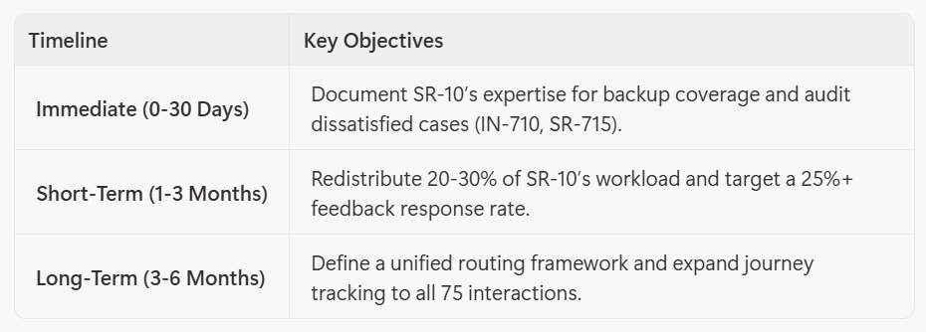

Conclusion
The dashboard reveals premium support achieving 5.00 average satisfaction with VIP-focused workload (44.4% P1, 33.3% P2), but faces critical risks: extreme SR-10 concentration, low feedback capture (5.3%), and contradictory rating mechanisms. Successful service recovery (IN-710, SR-715) demonstrates organizational capability, but strategic focus must address expertise distribution, feedback participation, and rating system standardization while maintaining exceptional satisfaction levels.

